**Course completion task**

**Set A**

1. Create Grafana dashboard with more than 8 matrixes. Using Prometheus check other 4 more Server monitoring

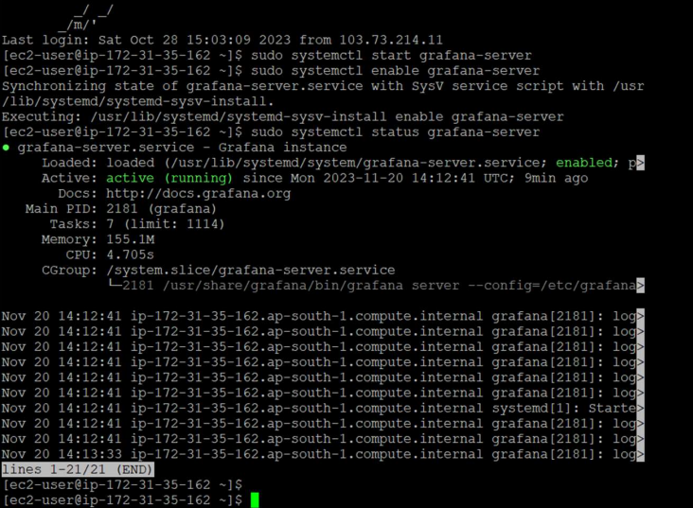

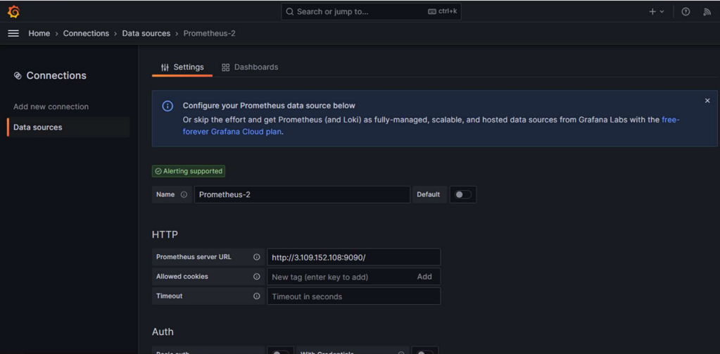

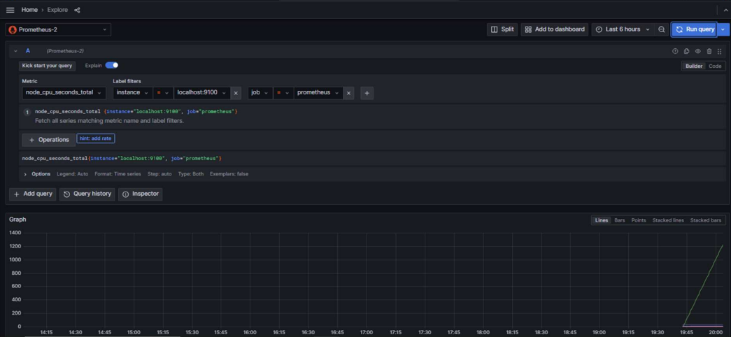

**2.** Setup your code on a Docker container using Jenkins on AWS

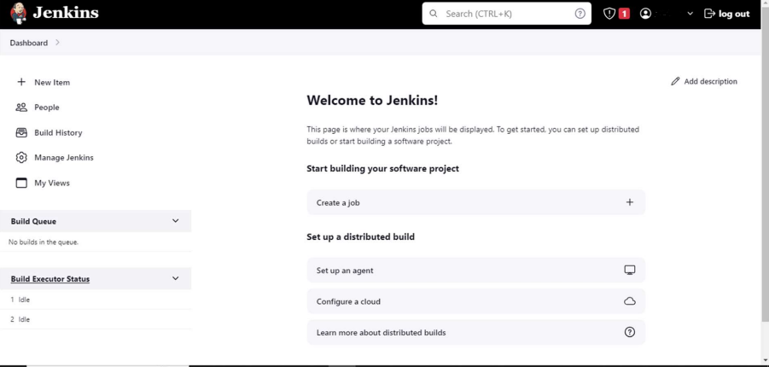

3. Jenkins

a. Install Jenkins from scratch on an ec2 instance with default plungins.

b. Create 3 users in Alice/Bob/Mary with different roles.

c. create free style project and execute various Linux commands in Build > Execute shell

d. install a git plugins and configure repo LuisJoseSanchez/hello-world-java: Hello world with Java (github.com) into it.

e. Execute the commands given in the repo description and the output should be printed into jenkins console.

f. Fork the repo, changes the description in print statement into code and rerun the Jenkins job the updated output should be shown into Jenkins console log.

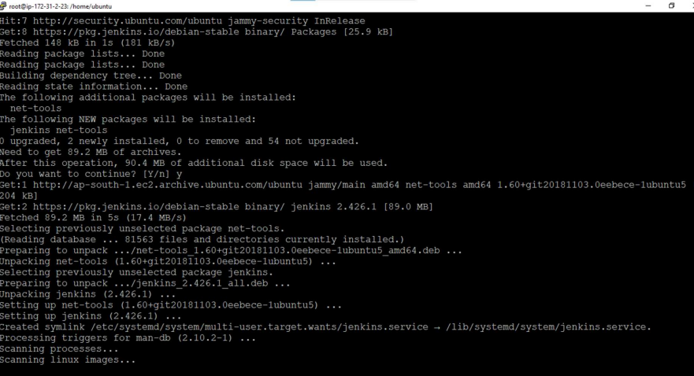



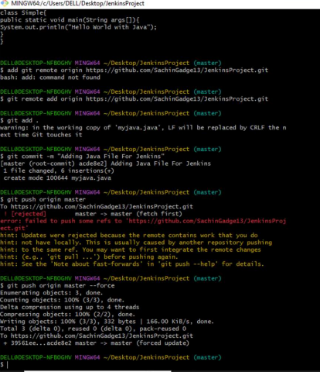

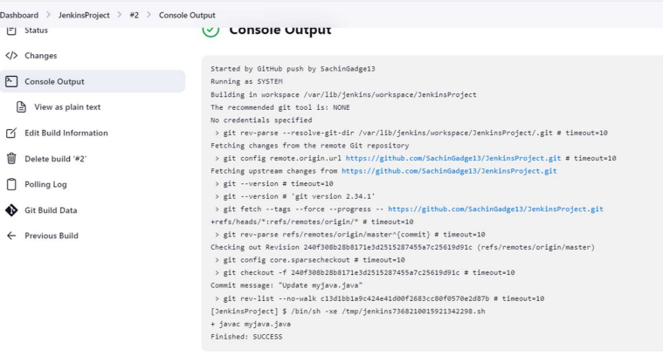

**Assignment Tasks:**

1. Ansible Installation and Configuration Install Ansible on a control node

2. Configure Ansible to work with your target servers. This may involve

3. SSH key setup, inventory file creation, and configuration management.

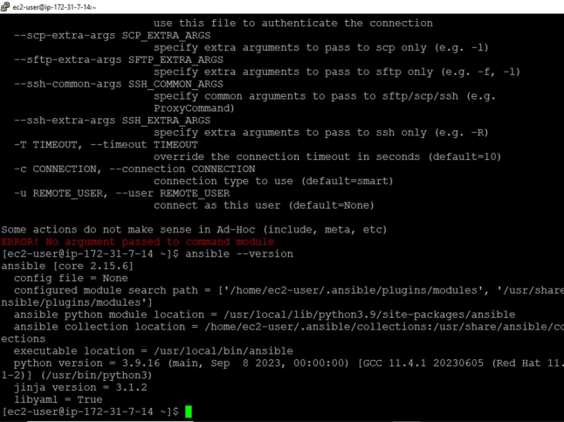

* Inventory Management Create an Ansible inventory file that lists all your target servers (min 2)
* Organize the servers into groups based on their roles (e.g., web servers, database servers).
* Verify that you can successfully ping the servers using Ansible Ansible command.

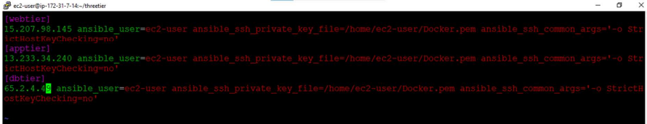

Automation Playbooks

1. Write an Ansible playbook that automates the installation and configuration of a commonly used software package (e.g., Nginx, Apache, MySQL) on your target servers.

2. Ensure the playbook includes tasks for package installation, configuration file management, and service management.

3. Execute the playbook and verify that the software is correctly installed and configured on all target servers.

